Keyword Ranking Graph
In this graph you can monitor in real time for each keyword and its corresponding website the changes in ranking for over +150 search engines, and compare the relative changes in placement between your site and that of your competitors for specific keywords.
You can also filter the data according to search engine selected (or multiple), the date range, and the rank range from top 10 to top 100 listing for each keyword.

You will see the ranking changes for your keywords online.
See your keyword rankings as they climb up.
Spot new competitors when they begin promoting their web site.
Control your rankings at all times.
Put your SEO strategy to the test. See if what you know really works.
Monitor your SEO budget or SEO manager's effectiveness.
Give reports to your customers - they will love it

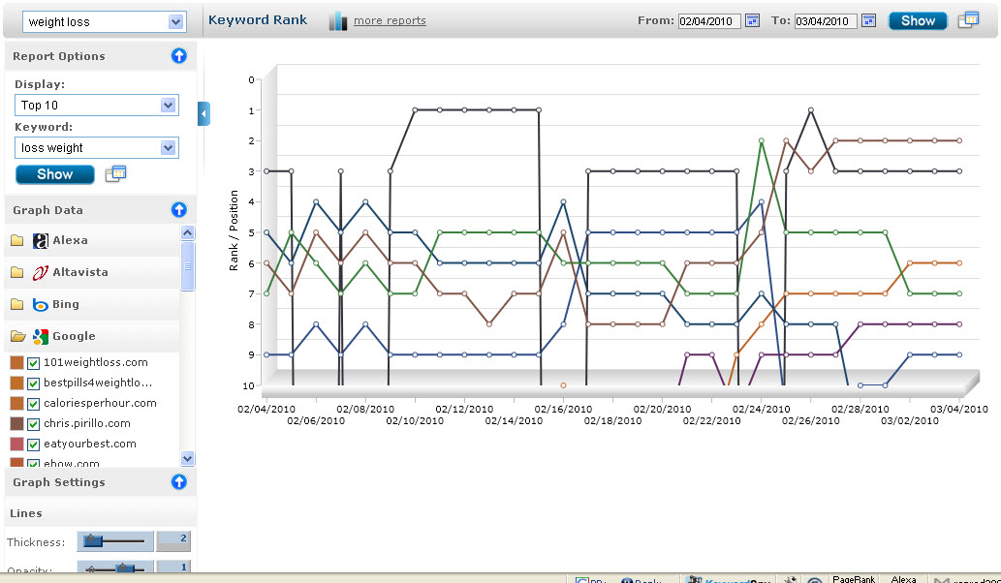

No more checking your keyword rankings manually -- the RankRanger does all the work for you

Monitor each keyword and its corresponding website for the changes in ranking.
See the date range and the rank range from top 10 to top 100 listings.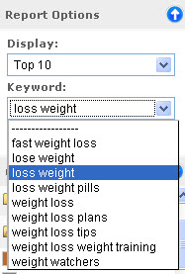
You can filter the data according to the search engine you selected. 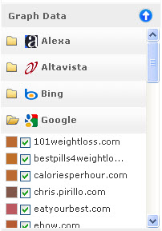

You will have full control of the graph output and settings.

