Keywords vs. Search Engines
In this table you can view the page ranking for different keywords by URL,
across multiple search engines and over a selected date range.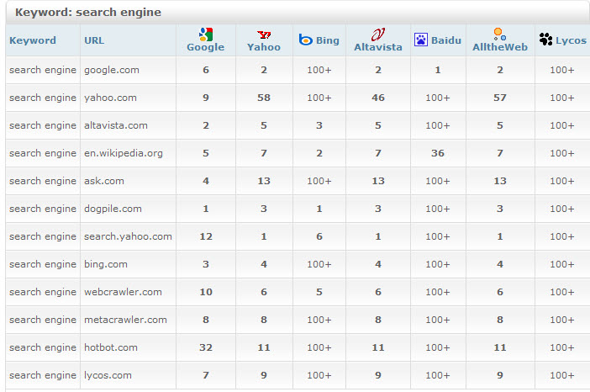

URL vs. Search Engines
In this table you can view the page ranking by URL for different keywords,
across multiple search engines and over a selected date range.
