URL Address Ranking Summary
Keyword Ranking Summary
Search Engine Ranking Summary

With this vital information you can easily monitor the latest keyword ranking changes of your website and competitor's websites.
Conduct your own marketing analysis and update your strategy in order to maximize results.
Learn how your SEO efforts influence your keyword ranking in the search engines.
Learn from your competitor's monitoring of their own website and the changes they make that affect their rankings.

URL Address Ranking Summary
You can view in this table a summary view of the page ranking filtered by URL and search engine over the last week and last month (presents the site rankings and directional change - up or down).
You can also view here Google Page Rank, the total number of pages in the site and number of links directed to the site.
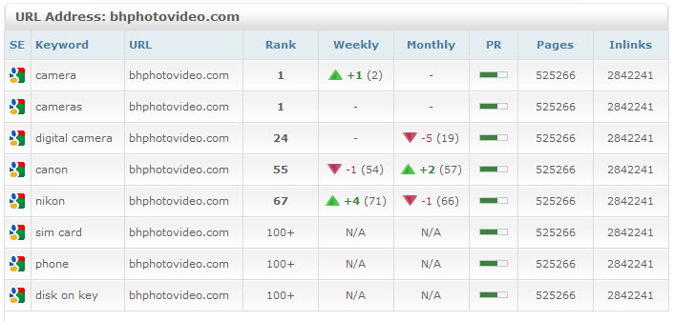
Keyword Ranking Summary
You can view in this table a summary view of the page ranking filtered by key word, site and search engine over the last week and last month (presents the site rankings and directional change - up or down).
You can also view here Google Page Rank, the total number of pages in the site and number of links directed to the site.
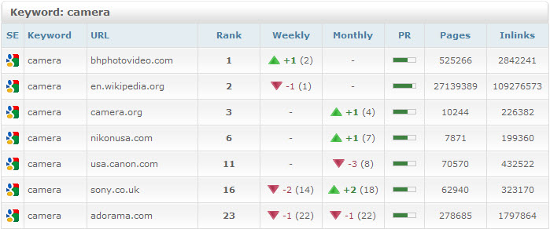

Search Engine Ranking Summary
In this table you can view a summary view of the page ranking filtered by search engine, URL and keyword over the last week and last month (presents the site rankings and directional change - up or down).
You can also view here Google Page Rank, the total number of pages in the site and number of links directed to the site.
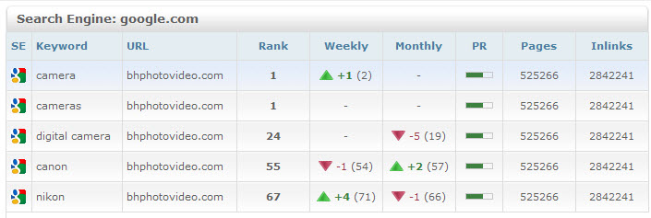

You can easily choose the information that you want to present.
