URL Ranking Graph
You can see in this graph how your site is ranked by the selected keyword, which gives you an updated report according to site exposure on the net and its ranking on different search engines.
You can monitor your site progress relative to many different keywords. This function also allows you to receive a progress report relative to competitors' use of the same key words, and to infer if they are starting to promote these keywords based on the trend. The data is presented by date and according to the maximum ranking selected.
Find out which keyword you competitor chose to promote, and in which search engines he or she promotes them.
The RankRanger will keep track and save all the data of your ranking history.

Are you an SEO marketing manager?
The URL Ranking Graph provides a great solution for internet marketing companies -- for example:
When a customer calls you and asks you, "what is my site ranking?"
Well, they usually ask for a report of at list 10 keywords for 3 different search engines, if not a report on their total keyword ranking history.

What reports are you providing for your customers?

Do you know the real keyword rankings performance of your website in Google, Yahoo and the other search engines?
Give your customer a full URL Ranking review, based on their particular interest level!

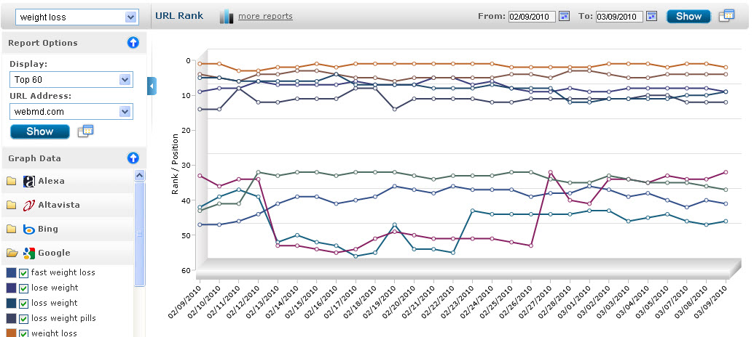
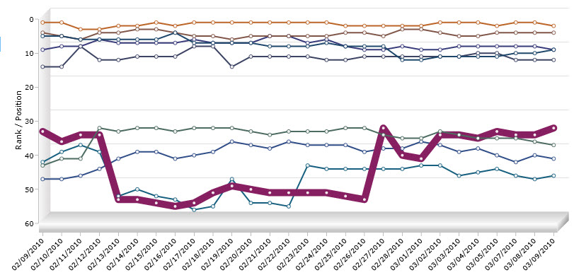
Monitor for each keyword and its corresponding website the changes in ranking.

Produce a report on the top 100 keywords for any site, according to date range.

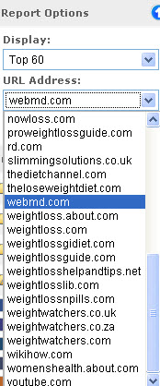

You can filter the data according to search engine you selected.

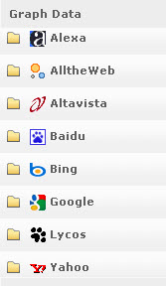

You will have full control over the graph settings.

